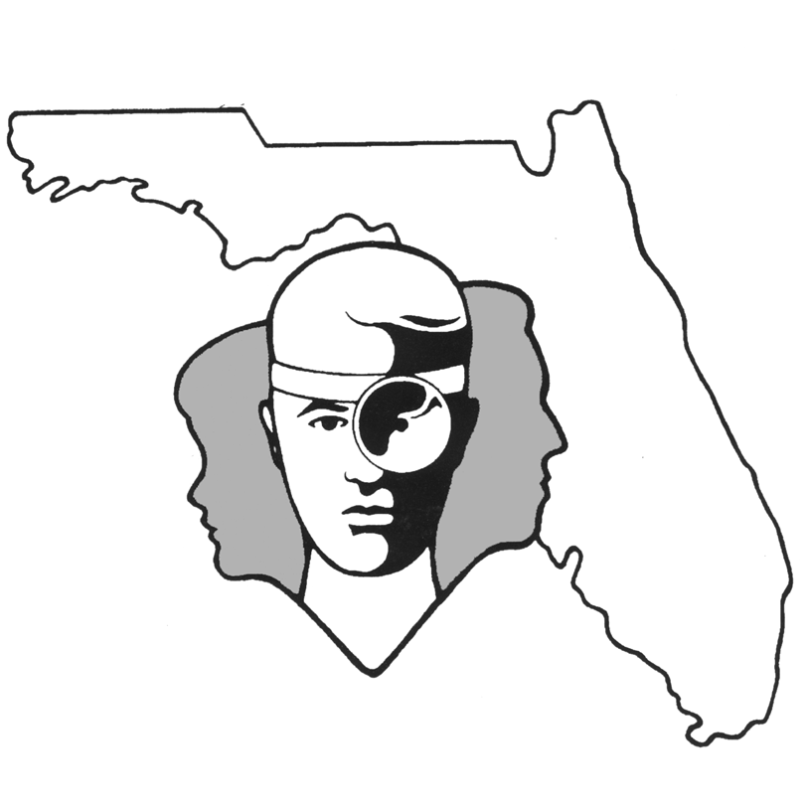
TALLAHASSEE EAR, NOSE & THROAT - HEAD & NECK SURGERY, P.A.
.
www.TallyENT.com Phone: (850) 877-0101

ADENOIDECTOMY

Your physician has recommended that you or your child undergo an adenoidectomy. The adenoids are a tonsillar-type tissue, which is located at the back of the nose, just behind the soft palate. Anatomically, the adenoids are important because they can obstruct the nasal end of the Eustachian tube, which allows the ear to equalize pressure and to drain fluid; can potentially plug the posterior nasal passages and block nasal breathing and nasal drainage; and because they are important in the closure of the palate against the back wall of the throat when speaking and swallowing.

The adenoids are directly adjacent to the Eustachian tubes and are felt to contribute to ear disease for a variety of reasons. They are sometimes large enough that they can mechanically obstruct the openings of the Eustachian tube and therefore block air from getting up into the ear and fluid from getting back out of the ear. They also potentially serve as a source of constant bacteria, which can then go up the Eustachian tubes and repeatedly infect the ears. Some people have also proposed that the adenoids can block drainage of fluid from the tissues around the Eustachian tube and therefore cause it to swell shut. Generally, the adenoidectomy is used as a supportive measure in children who have had a repeated need for tube placement or for those who have other symptoms of adenoid enlargement in conjunction with their ear problems.

The adenoids, because of their location, can potentially block the back of the nose above the palate. The adenoids can physically grow into the back portion of the nose and disrupt the adequate movement of air. This can lead to a number of different problems, including snoring, chronic mouth breathing, obstructive sleep apnea, and dental misalignment. The adenoids also can impair the drainage of mucus and lead to chronic runny noses. It also has been proposed as a source for repeated sinus infections.

Lastly, the adenoids have been shown to serve some function in terms of palatal closure when people drink or speak. Generally, the only sounds we make which are not associated with a completely closed-off nasal passageway are the sounds “m”, “n”, and “-ing”. With all other sounds, the palate swings up and closes against the back wall of the throat, where the adenoids are located. Removal of the adenoids can potentially cause a decreased ability of the patient to close the palate when speaking or drinking, leading to the escape of air or liquid into the nose. This problem is called velopharyngeal insufficiency.

The risks of the adenoidectomy are relatively small, including a small risk of bleeding (<1%), which is significantly less than the risk of doing a tonsillectomy. There also, as noted above, is a small chance of developing velopharyngeal insufficiency with a risk generally of less than 1 in 1,500. Your physician will determine whether or not your child has a small midline defect in the musculature of the palate, which would increase the chances of the development of velopharyngeal insufficiency. If this is noted before surgery, this will be mentioned during your child’s preoperative evaluation. Additionally, you should notify your surgeon if anyone in the family has a history of “cleft palate” or “cleft lip”. An additional risk is the potential to develop scarring in the back of the nasopharynx, potentially leading to a narrowing of the nasal airway. This nasopharyngeal stenosis or scarring is an extremely rare postoperative complication.

Adenoidectomy is frequently performed in conjunction with other procedures, such as placement of ventilation tubes in the ears or removal of the tonsils. Separate information sheets should be given to you preoperatively on any other procedures.

